gain web visitors and eventually convince them to support the website based on some surveys gathered by the past studies. The proponents conducted a research on the business process of Fortis Technologies, Fortis technologies Inc. is using Gmail in receiving the request support from the clients and responding to the clients on the status of the sent request from the clients. Every day, each of the Fortis Technologies developers receives almost 50 e-mails they mostly encountered the problems in tracking the e-mails and identifying what e-mails are already solved and unresolved. Lots of email traffic requesting help, services, etc. Developers facing difficult to find current status or problem history, and sometimes problems were forgotten or never resolved. They can't identify what e-mail should be prioritized, some of the developers usually wait for the direction of their senior, and it will cause delay on the response in the issue.

Therefore the proponents decided to create an Online Ticketing System for Fortis Technologies that will help the business process of the Fortis Technologies. The Fortis Technologies can easily identify the problems and will easily response to the client’s request.

**Purpose and Description of the Project**

The purpose of creating an Online Ticketing System is to help and enhance the effectiveness of the Fortis Technologies Corporation, to easily monitor and identify the mails, issues, status of the ticket. That will increase the subscriber for Fortis Company.

The Online Ticketing System can track the problem that was requested by their clients and the Fortis Company Administrator can easily track or monitor who is assigned in one particular task that the client sent. The client can easily check or monitor the status of their requests. The client of the Fortis Technologies Corp can create comments to the issue. The request will be kept for future reference and will be monitored even if the developers solved the problem.

The proposed system will benefit the following:

1. **The Company** Online Ticketing System can help the Fortis Technologies Inc. to easily respond to the problem was requested by their clients.
2. **The Employees** can easily handle the problems that are being reported by their clients.
3. **The proponents** can enhance and improve their skills to resolve and learn about different problem in implementing the system, and the proponents are updated on what is happening in the industry.
4. **The Future Researchers.** The benefits for the future researchers are by getting an idea for develop a system is when the future researchers read the documents about thesis project. The future researchers also get encourage and motivation by developing a system when the future researches read about the review of related literature and study.

The target of the proposed Ticketing System is the Fortis Technologies Inc. developers. The beneficiaries of this system are:

**Objectives**

The goal of the researchers is to help Fortis Technologies inc. Developing a technology for the company’s productivity should be the main concern of the developer. As stated, the state shall give priority to research and development, invention, innovation, and their utilization have a good service for the clients who will inquire to the website and the services such as support process.

Specifically it aims to:

* Give clients a satisfaction regarding Online Ticketing System.
* To avoid lost and redundancy in keeping and storing of Tickets information.
* To easily find the ticket information.
* To reduce man power for managing new and old Tickets .

**General objectives**

The general objective of the study is to develop an Online Ticketing System for Fortis Technologies Inc.

* Specifically it aims to: create a module which the clients of Fortis Technologies Corp. can send requests.
* Specifically it aims to: create a module that will show the status and severity of the ticket requested by the client.
* Specifically it aims to: create an administrative module that will let the administrator to monitor how fast the developers of Fortis Technologies Corp respond on one specific request.
* Specifically it aims to: reduce the delay on the response on the issue send by the client.

**Scope of the Project**

The purpose of the study of the Online Ticketing System for Fortis Technologies Inc. is to create a system that will lessen the entire process of the business.

The system can also add tickets that are requested or will be sent by the clients; the clients can also view the status of the tickets and add comments to the issue.

The software provides administrator module will assign a default email address and a default password to the clients. Administrator can monitor the developers on how fast to respond on the tickets that are assigned to the developers. The Administrator module has a user maintenance module that will enable him to add user, deactivate user, and import user to the system.

The result showed that the quality issues arose from two main areas; resolution time of requests and professionalism of IT staff. The quality issues are, according to both the quantitative and qualitative analysis, caused by high workload for one of the IT department’s teams and high expectations of the organization. Furthermore, this study emphasizes that alignment between IT department and organization is an issue of both sides, as alignment concerns mutual understanding and communication. To solve the service quality issues this study recommends starting to work with measurability and continuous improvements, for example Lean Six Sigma. The IT department can strive to increase the interdepartmental communication, share work tasks, educate internally, document competences and clarify responsibilities to decrease the workload.

According Fazira Shafie & Wan Zahari Wan Yusoff In higher educational institutions, students, academic staff, and non-academic staff can be categorized as users since they make use of the services and products provided. The purpose of this paper is to provide an exploratory look at how facilities management (FM) helpdesk can be applied in higher educational institutions, with case study at University Tun Hussein Onn Malaysia (UTHM). It discusses the manner in which the FM helpdesk functions as a user complaint system in improving the delivery of facilities management (FM) services in a public university. The research objectives are to study the existing service management system for users’ complaint on facilities management and whether that system can contribute to user satisfaction in UTHM. A case study methodology was adopted, with semi-structured interviews and actual data collected generated from the monthly and annual report of FM helpdesk to analyze. These showed the total numbers of users’ complaints about facilities management in UTHM. Therefore, the intents of this research are to know the effectiveness of the FM helpdesk as a user complaint system and also to obtain feedback on users’ satisfaction using this system. As a result, this system could be a good tool to enhance the systematic management of users’ complaints for better facilities management in UTHM.

**2.3 Local**

**3.3 System Design**

Review Report Request

Client

Report Bug Information

Request details

Client

Reports

Fix Bug

Update Ticket Record

Tickets

Notify User

Notify User

**3.4 Development Testing and Testing**

**Description of the Prototype**

**Login Form**

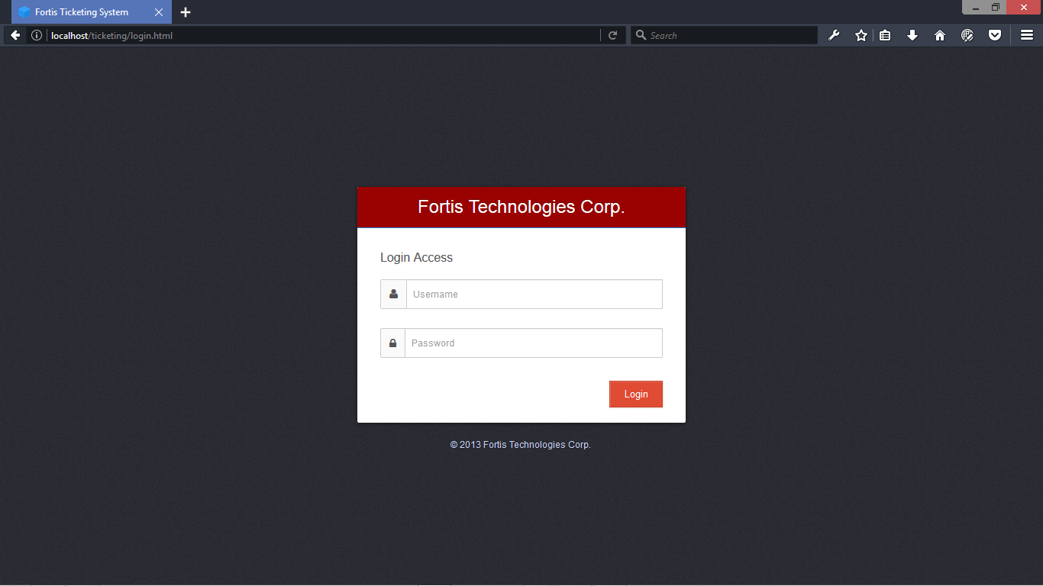

This page is used to open a session with an account that is already created.

**Admin Index**

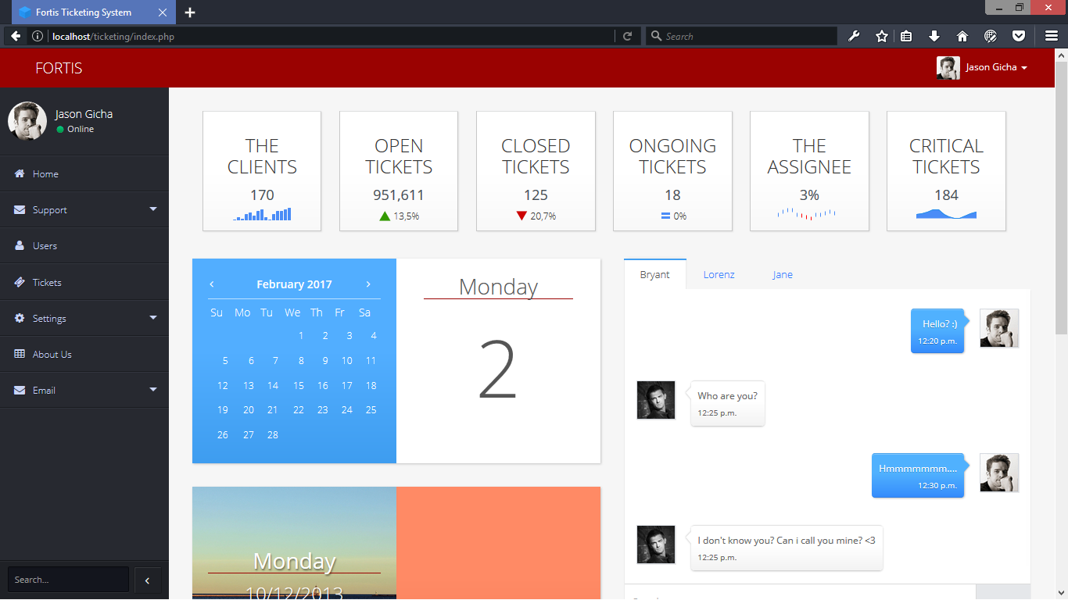

This Admin Index Module will use to see and to manage the system.

**Create Ticket**

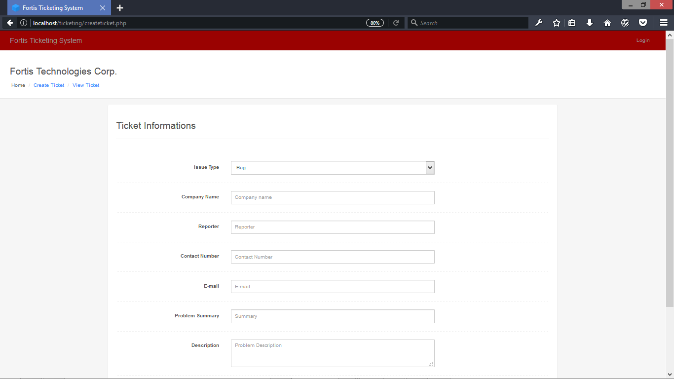

This Create Ticket Module can create ticket that will be use for transaction with the company

**Setting Resolution**

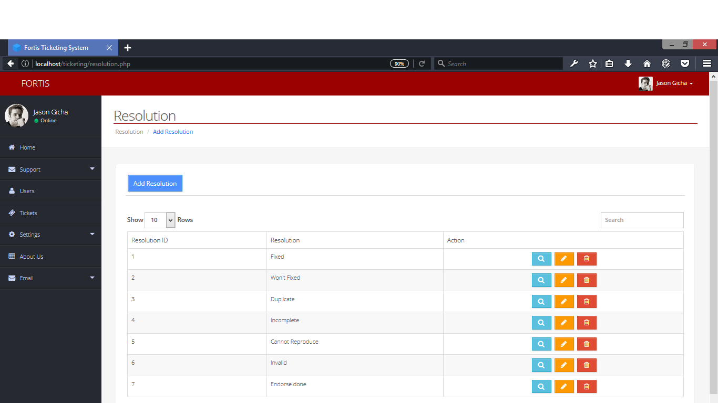

This Setting (Resolution) Module can Add, Edit, Delete the resolution of the ticket.

**Setting Status**

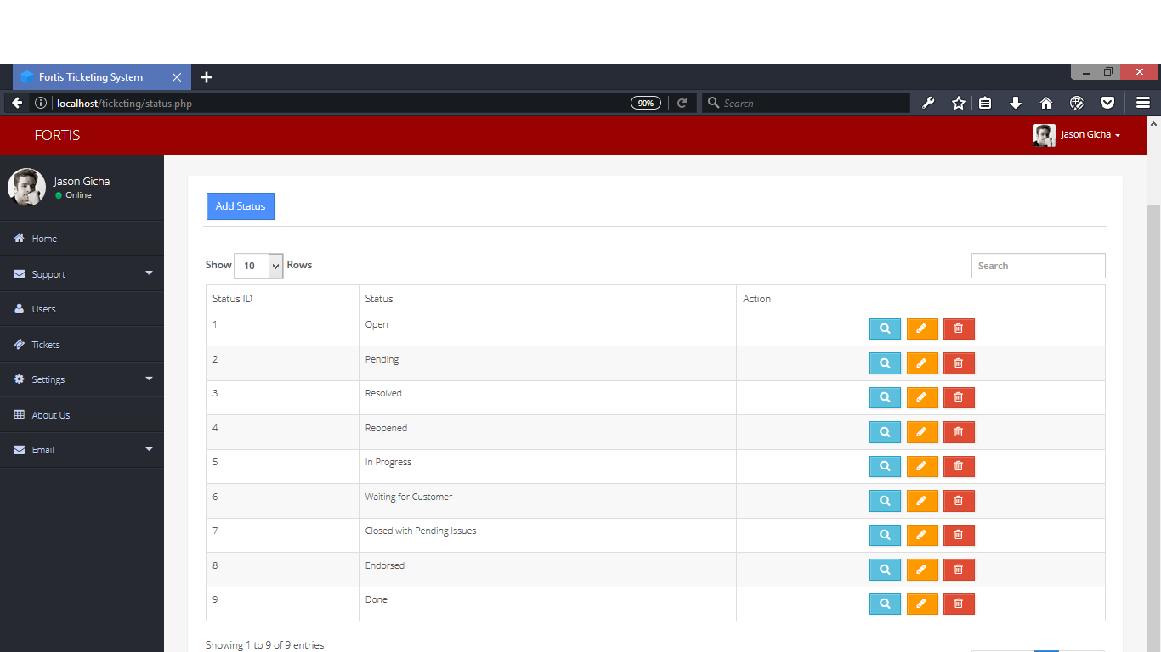

This Setting (Status) Module can Add, Edit , Delete the status of the ticket.

**Setting Severity**

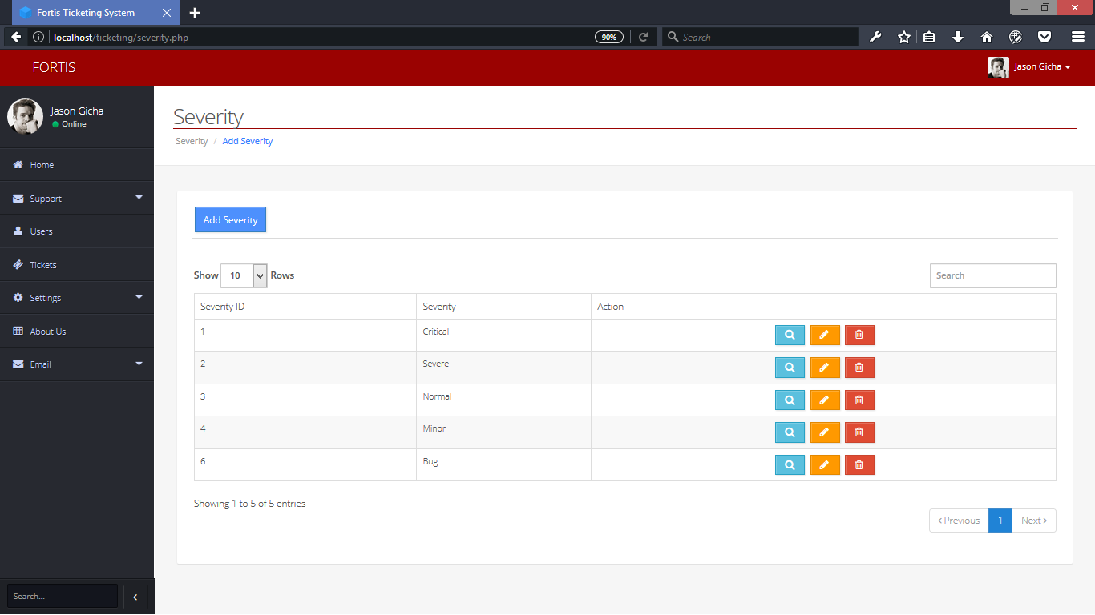

This Setting Severity Module Can Add, Edit, Delete the severity of the ticket.

**3.6 Implementation plan**